1. 1. Question

TRUE OR FALSE  
After users are enrolled in MFA they must configure a  second authentication factor the next time they sign in

* +  FALSE
  +  TRUE

Unattempted

1. 2. Question

You are a Microsoft 365 administrator. You need to implement the appropriate features for this scenario. What should you implement?  
“Secure members of the Global Administrators Group by using dynamic risk profiles”

* +  Microsoft Azure AD Conditional Access
  +  Microsoft Azure AD Identity Protection
  +  Microsoft Azure AD Privileged Identity Management

Unattempted

Identity Protection is a tool that allows organizations to accomplish three key tasks:  
Automate the detection and remediation of identity-based risks.  
Investigate risks using data in the portal.  
Export risk detection data to third-party utilities for further analysis.

<https://docs.microsoft.com/en-us/azure/active-directory/identity-protection/overview-identity-protection>

1. 3. Question

TRUE OR FALSE  
Compliance Manager performs assessment against your entire Microsoft 365 environment and evaluates both Microsoft and Customer controls.

* +  Yes
  +  No

Unattempted

Microsoft Compliance Manager (preview) is a free workflow-based risk assessment tool in the Microsoft Service Trust Portal for managing regulatory compliance activities related to Microsoft cloud services. Part of your Microsoft 365, Office 365, or Azure Active Directory subscription, Compliance Manager helps you manage regulatory compliance within the shared responsibility model for Microsoft cloud services.  
Microsoft-managed controls  
For each cloud service, Microsoft implements and manages a set of controls as part of Microsoft’s compliance with various standards and regulations. Each control provides details about how Microsoft implemented the control, and how and when that implementation was tested and validated by Microsoft and/or by an independent third-party auditor.  
Customer-managed controls  
Customer-managed controls are managed by your organization. Your organization is responsible for customer-managed control implementation as part of your compliance process for a given standard or regulation. Customer-managed controls are organized into control families for the corresponding certification or regulation. Use the customer-managed controls to implement the recommended actions suggested by Microsoft as part of your compliance activities. Your organization can use the prescriptive guidance and recommended customer actions in each customer-managed control to manage the implementation and assessment process for that control.  
<https://docs.microsoft.com/en-us/microsoft-365/compliance/compliance-manager-overview?view=o365-worldwide>

1. 4. Question

A company purchases Microsoft 365 E5.

You need to determine which security features you should implement.

Which features should you implement” To identify sensitive data and create policies that help prevent users from accidentally or intentionally sharing the data?

* +  Customer Lockbox
  +  Data Loss Prevention
  +  Microsoft Office 365 Advanced Threat Protection
  +  Microsoft Office 365 secure score

Unattempted

1. 5. Question

You need to reduce the amount of time that the IT team spends on user support. What are the three possible ways to achieve this goal?  
Note that each correct answer presents a complete solution

* +  Deploy Microsoft my analytics to devices
  +  Enable Microsoft Office 365 customer lockbox
  +  Deploy Microsoft Office 365 Enterprise to all client devices
  +  Use windows autopilot to deploy devices
  +  Upgrade all client devices to Windows 10

Unattempted

1. 6. Question

You are the Microsoft 365 administrator for a company.

Your company plans to open a new office in the United Kingdom.

You need to provide penetration tests and security assessment reports for the new office.

Where can you locate the required reports?

* +  Data Loss Prevention page of the Security and Compliance portal
  +  Compliance Manager page of the Services Trust portal
  +  Data Governance page of the Security and Compliance portal
  +  Regional Compliance page of the Services Trust portal

Unattempted

Microsoft Service Trust Portal (Industries & Regions section)  
Provides industry- and region-specific compliance information about Microsoft Cloud services.  
Industries: At this time, this page provides an industry-specific landing page for the Financial Services industry. This contains information such as compliance offerings, FAQs, and success stories. Resources for more industries will be released in the future, however, you can find resources for more industries by going to the Trust Documents > Data Protection page in the STP.  
Regions: Provides legal opinions on Microsoft Cloud services compliance with various laws of various countries. Specific countries include Australia, Canada, Czech Republic, Denmark, Germany, Poland, Romania, Spain, and the United Kingdom.

<https://docs.microsoft.com/en-us/microsoft-365/compliance/get-started-with-service-trust-portal?view=o365-worldwide>

1. 7. Question

You need to configure a data governance solution for your company. You know the complete solution must meet the following requirements:

-> Classify documents

-> Ensure that classifications are enforced

-> Delete documents that are no longer used

Which actions should you perform to perform 2nd step i.e. Ensure that classifications are enforced?

* +  Configure Microsoft Outlook mail tips
  +  Configure document approval
  +  Apply supervision policies

Unattempted

Supervision allows you to set policies to monitor email and 3rd party communications in your organization. You can specify people to review these communications.  
<https://www.recordpoint.com/blog/advanced-data-governance-labels/>

1. 8. Question

You need to configure a data governance solution for your company. You know the complete solution must meet the following requirements:

-> Classify documents

-> Ensure that classifications are enforced

-> Delete documents that are no longer used

Which actions should you perform to perform 1st step I.e. Classify documents?

* +  Apply  Microsoft SharePoint permissions
  +  Publish Labels
  +  Define File and Folder Structures

Unattempted

Classify your information for governance purposes. For example, you could have a label for a contract, employee review, or another type of information. Labels can also have a retention policy associated with it.  
<https://www.recordpoint.com/blog/advanced-data-governance-labels/>

1. 9. Question

You are the Microsoft 365 administrator for a company.

You need to identify available cloud security features.

Match this feature to the correct description.  
Block users from accessing cloud apps from certain devices.

* +  Microsoft Azure AD Conditional Access
  +  Cloud Discovery Dashboard
  +  Microsoft Azure Security Centre
  +  Microsoft Azure Information Protection

Unattempted

<https://docs.microsoft.com/en-us/azure/active-directory/conditional-access/overview>

1. 10. Question

You are the Microsoft 365 administrator for a company.

You need to identify available cloud security features.

Match this feature to the correct description.  
Classify and label e-mails and documents in the organization.

* +  Microsoft Azure Security Centre
  +  Microsoft Azure AD Conditional Access
  +  Cloud Discovery Dashboard
  +  Microsoft Azure Information Protection

Unattempted

<https://www.microsoft.com/en-us/itshowcase/using-azure-information-protection-to-classify-and-label-corporate-data>

1. 11. Question

A company is moving to Microsoft Azure. Some applications cannot be moved. You need to identify which applications will remain in a hybrid environment after the migration. Which applications will remain in a hybrid environment?

* +  legacy applications that use a message-based interface
  +  applications that use a USB-token device to control access
  +  a new server that runs several line-of-business applications
  +  applications that manage sensitive information

Unattempted

A hybrid cloud combines public and private clouds, allowing you to run your applications in the most appropriate location. For example, you could host a website in the public cloud and link it to a highly secure database hosted in your private cloud (or on-premises data-center). In hybrid scenario’s most companies will keep the most sensitive databases on-premises and move everything else to the cloud.  
<https://docs.microsoft.com/en-us/learn/modules/principles-cloud-computing/4-cloud-deployment-models>

1. 12. Question

A company plans to migrate to Microsoft 365.

You need to advise the company about how Microsoft provides protection in a multitenancy environment.

What are the three ways that Microsoft provides protection? Each correct answer presents part of the solution. (Choose three.)

NOTE: Each correct selection is worth one point.

* +  Customer content at rest is encrypted on the server by using BitLocker.
  +  Customer content in transit is encrypted on the server by using transport-layer security (TLS).
  +  Logical isolation of customer content within each tenant for Microsoft 365 services is achieved through Azure Active Directory authorization and role-based access control.
  +  Mailbox databases in Microsoft Exchange Online contain only mailboxes from a single tenant.
  +  Microsoft Azure AD provides authorization and role-based access control at the transport layer
  +  Mailbox databases in Microsoft Exchange Online contain mailboxes from multiple tenants.

Unattempted

<https://docs.microsoft.com/en-us/office365/Enterprise/office-365-tenant-isolation-overview>

1. 13. Question

A company purchases Microsoft 365 E5.

You need to determine which security features you should implement.

Which features should you implement for “Providing recommendations to reduce risk”?

* +  Microsoft Office 365 secure score
  +  Customer Lockbox
  +  Data loss prevention
  +  Microsoft 365 Advanced Threat Protection

Unattempted

Microsoft Secure Score is a representation of your organization’s security posture, and your opportunity to improve it.

1. 14. Question

True or False  
To enable or disable targeted releases in an organization, select each user who should receive early access to features and functionality from a list.

* +  TRUE
  +  FALSE

Unattempted

In-Office 365 admins can choose how their company or individuals in the company receive updates.  
While the default option is our Standard release and updates are pushed to your tenant as they become broadly available, you can also opt in to the Targeted release option (formerly known as First Release). In the latter case, you and your users will be the first to see the latest updates and can help shape the product by providing early feedback.  
Set up the release option in the admin center  
You can change how your organization receives Microsoft 365 updates by following these steps. You have to be a global admin in Microsoft 365 to opt-in.  
In the admin center, go to the Settings > Org Setting, and under the Organization profile tab, choose Release preferences.  
To disable targeted release, select Standard release, then select Save changes.  
To enable targeted release for all users in your organization, select Targeted release for everyone, then select Save changes.  
To enable targeted release for some people in your organization, select Targeted release for selected users, then select Save changes.  
Choose Select users to add users one at a time, or Upload users to add them in bulk.  
When you’re done adding users, select Save changes.

1. 15. Question

TRUE OR FALSE  
Cloud solution providers can bill customers for Microsoft 365 licenses on an annual basis.

* +  Yes
  +  No

Unattempted

Cloud Partners(CSP) own and control the billing cycle (monthly or annually)

1. 16. Question

A company deploys Microsoft Azure AD. You enable multi-factor authentication. You need to inform users about the multi-factor authentication methods that they can use. Which of the following methods is NOT a valid multi-factor authentication method in Microsoft 365?

* +  Insert a small card into a desktop computer and provide a PIN code when prompted
  +  Receive an automated call on the desk phone that includes a verification code
  +  Receive an SMS text message that includes a verification code
  +  Receive a call on a mobile phone and select the pound sign (#) when prompted

Unattempted

When a user signs in to an application or service and receives an MFA prompt, they can choose from one of their registered forms of additional verification. An administrator could require registration of these Azure Multi-Factor Authentication verification methods, or the user can access their own My Profile to edit or add verification methods.  
The following additional forms of verification can be used with Azure Multi-Factor Authentication:  
Microsoft Authenticator app  
OATH Hardware token  
SMS  
Voice call

For more information:  
<https://docs.microsoft.com/en-us/azure/active-directory/authentication/concept-mfa-howitworks>

1. 17. Question

A company deploys Exchange Online and SharePoint Online.

You must audit and assessment report for the Microsoft 365 cloud services that the company uses.

You need to provide the required documents.

Which Microsoft site should you use to obtain this information?

* +  Compliance Manager
  +  Azure portal
  +  Service Trust Portal
  +  Office 365 Security and Compliance Center

Unattempted

<https://servicetrust.microsoft.com/ViewPage/TrustDocumentsV3?docTab=7f51cb60-3d6c-11e9-b2af-7bb9f5d2d913_FAQ_and_White_Papers>

1. 18. Question

An organization is considering migrating some of its resources to the cloud. The company does not plan to deploy Microsoft AzureExpressRoute or site-to-site VPNs. You need to identify if this workload can migrate to the cloud by choosing the best answer.  
” A legacy application that requires connectivity to on-premises data store”

* +  Remain On-premise
  +  Migrate to Cloud

Unattempted

1. 19. Question

An organization is considering migrating some of its resources to the cloud. The company does not plan to deploy Microsoft AzureExpressRoute or site-to-site VPNs. You need to identify if this workload can migrate to the cloud by choosing the best answer.  
” You need to deploy  a Microsoft SharePoint collaboration site for partners”

* +  Remain On-premise
  +  Migrate to Cloud

Unattempted

1. 20. Question

You are a Microsoft 365 administrator for a company where employees use Microsoft Office 365 Enterprise to create documents. You need to implement document classification and protection by using Microsoft Information protection which  actions should you perform each current each correct answer presents part of his solution And is worth one point

* +  install the Azure information protection client
  +  Install the rights management service client
  +  add on Azure subscription to your Microsoft 365 tenant
  +  create a custom Azure information protection policy with confidential label
  +  enable the default Azure information protection policy an option is installed the rights management service client

Unattempted

<https://docs.microsoft.com/en-us/azure/information-protection/what-is-information-protection>

1. 21. Question

An organization plans to deploy Microsoft Intune.

For the following statement, select Yes if the statement is true. Otherwise, select No.  
“Microsoft Intune can define where corporate data is stored”

* +  Yes
  +  No

Unattempted

App protection policies make sure that the app-layer protections are in place. For example, you can:  
Require a PIN to open an app in a work context  
Control the sharing of data between apps  
Prevent the saving of company app data to a personal storage location

<https://docs.microsoft.com/en-us/search/?scope=Office%20365%20Enterprise&terms=microsoft%20intune&skip=10>

1. 22. Question

An organization is considering migrating some of its resources to the cloud. The company does not plan to deploy Microsoft AzureExpressRoute or site-to-site VPNs. You need to identify if this workload can migrate to the cloud by choosing the best answer.  
” You need to deploy the external-facing website”

* +  Migrate to Cloud
  +  Remain on-premise

Unattempted

1. 23. Question

This question requires that you evaluate the “Italicized”  text to determine if it is correct.

A company needs to protect documents and emails by automatically applying classifications and labels. You must minimize costs.  
You should implement Microsoft Azure Information Protection for Microsoft Office 365.

Review the above “italicized” text. If it makes the statement correct, select No change is needed. If the statement is incorrect, select the answer choice that makes the statement correct.

* +  Azure Information Protection Premium P1
  +  No change needed.
  +  Azure Information Protection Premium P2
  +  Microsoft 365 E3

Unattempted

<https://azure.microsoft.com/en-us/pricing/details/information-protection/>

1. 24. Question

TRUE OR FALSE  
Cloud Service Providers can provide 30 days of trial licenses to customers

* +  No
  +  Yes

Unattempted

CSP’s can’t provide any trial license to customers.

1. 25. Question

True or False  
By default, all the Microsoft 365 users are configured for “Targeted Release”

* +  No
  +  Yes

Unattempted

In-Office 365 admins can choose how their company or individuals in the company receive updates.  
While the default option is our Standard release and updates are pushed to your tenant as they become broadly available, you can also opt in to the Targeted release option (formerly known as First Release). In the latter case, you and your users will be the first to see the latest updates and can help shape the product by providing early feedback.

1. 26. Question

You are the Microsoft 365 administrator for a company. You install Microsoft Office 365 Enterprise on five devices. You deactivate the Microsoft Office 365 Enterprise license on one device.  
Which task can you perform on that device?

* +  Start a new document from a template
  +  Leave a comment in a document
  +  Create a document
  +  print a document
  +  Set properties on a document.
  +  Co-author a document.

Unattempted

When you deactivate a Microsoft Office 365 Enterprise license, Office 365 Enterprise remains installed on the computer, but you can only view and print documents. All features for editing or creating new documents are disabled.

1. 27. Question

You need to ensure that the process by which users sign in to Microsoft 365 confirms the identity of the user. Which feature should you use?

* +  Advanced Threat Protection (ATP)
  +  mobile application management (MAM)
  +  data loss prevention (DLP) policies
  +  Multi-Factor Authentication (MFA)

Unattempted

Multi-factor authentication is an electronic authentication method in which a computer user is granted access to a website or application only after successfully presenting two or more pieces of evidence (or factors) to an authentication mechanism: knowledge (something the user and only the user knows), possession (something the user and only the user has), and inherence (something the user and only the user is). It protects the user from an unknown person trying to access their data such as personal ID details or financial assets.  
<https://docs.microsoft.com/en-us/azure/active-directory/authentication/concept-mfa-howitworks>

1. 28. Question

You need to configure a data governance solution for your company. You know the complete solution must meet the following requirements:

-> Classify documents

-> Ensure that classifications are enforced

-> Delete documents that are no longer used

Which actions should you perform to perform 3rd step i.e. Delete documents that are no longer used

* +  Apply preservation policies
  +  Configure Microsoft SharePoint second-stage Recycle bin
  +  Apply retention policies

Unattempted

Retention policies ensure that you do not delete content prematurely. Once the content has reached the end of its retention period it can be deleted, start an approval process for deletion, or it can do nothing.  
<https://www.recordpoint.com/blog/advanced-data-governance-labels/>

1. 29. Question

You are a Microsoft 365 administrator. You need to implement the appropriate features for this scenario. What should you implement?  
“Secure admin roles by requiring approvals”

* +  Microsoft Azure AD Identity Protection
  +  Microsoft Azure AD Domain Services
  +  Microsoft Azure AD Privileged Identity Management

Unattempted

For Azure AD roles in Privileged Identity Management, only a user who is in the Privileged role administrator or Global administrator role can manage assignments for other administrators. You can grant access to other administrators to manage Privileged Identity Management. Global Administrators, Security Administrators, Global readers, and Security Readers can also view assignments to Azure AD roles in Privileged Identity Management.

<https://docs.microsoft.com/en-us/azure/active-directory/privileged-identity-management/pim-configure>

1. 30. Question

You are the Microsoft Office 365 administrator for a company.

You need to perform security and compliance reviews before new updates are distributed to the entire company.

What should you implement?

* +  FastTrack
  +  Microsoft 365 Enterprise Test Lab
  +  standard releases
  +  targeted releases

Unattempted

<https://docs.microsoft.com/en-us/office365/admin/manage/release-options-in-office-365?view=o365-worldwide>

1. 31. Question

A company purchases Microsoft 365 E5.

You need to determine which security features you should implement.

Which features should you implement for “Control how a Microsoft Support Engineer accesses data during a help session”?

* +  Microsoft Office 365 secure score
  +  Customer Lockbox
  +  Microsoft 365 advanced threat protection
  +  Data Loss prevention

Unattempted

Office 365 Customer Lockbox feature which will help a customer to control how a Microsoft support engineer is going to access customer data during a scenario where customers have raised a support request to investigate some service issues related to customers Office 365 tenant.

1. 32. Question

You are a Microsoft 365 administrator. You need to implement the appropriate features for this scenario. What should you implement?  
“Restrict access to Microsoft Outlook using a PIN”

* +  Device Configuration Policy
  +  Mobile Application Protection Policy

Unattempted

You can protect corporate data in Outlook for iOS and Android using Intune app protection policies. App Protection Policies (APP) define which apps are allowed and the actions they can take with your organization’s data. The choices available in APP enable organizations to tailor the protection to their specific needs.  
Enterprise basic data protection (Level 1) ensures that apps are protected with a PIN and encrypted and perform selective wipe operations. For Android devices, this level validates Android device attestation. This is an entry-level configuration that provides similar data protection control in Exchange Online mailbox policies and introduces IT and the user population to APP.  
Reference Read:  
<https://docs.microsoft.com/en-us/exchange/clients-and-mobile-in-exchange-online/outlook-for-ios-and-android/secure-outlook-for-ios-and-android>

1. 33. Question

A company deploys Microsoft Intune.

An employee loses a Windows 10 device that contains corporate data.

You need to ensure that the corporate data on the device is secured as quickly as possible.

Which two options can you use?  
To answer, select the appropriate actions in the answer area.  
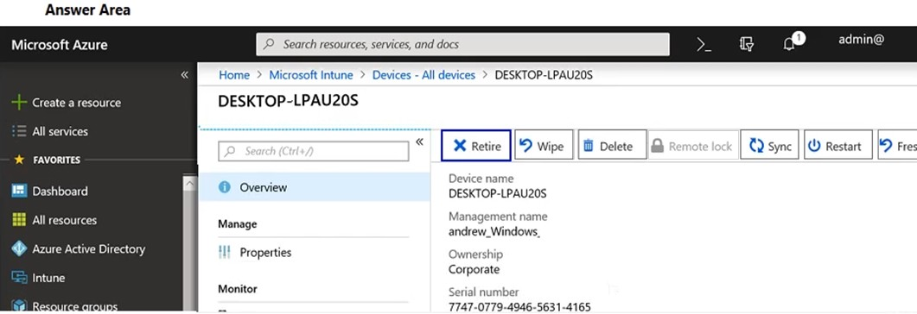

* +  Wipe and Delete
  +  Restart and Delete
  +  Sync and Restart
  +  Retire & Wipe

Unattempted

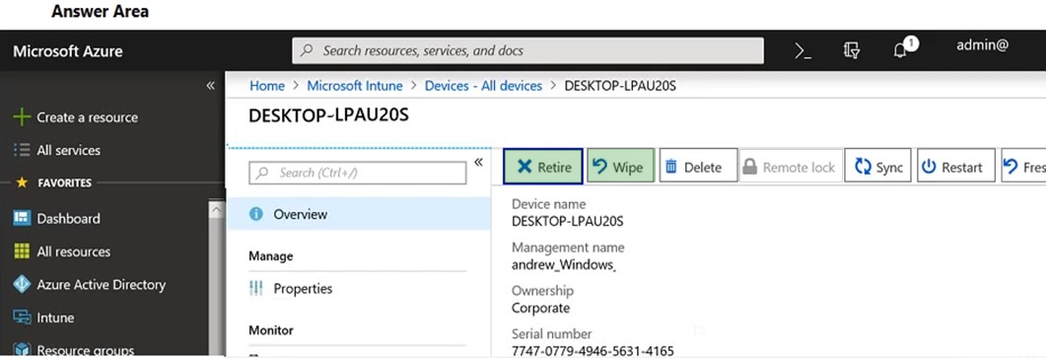

1. 34. Question

A company plans to migrate to a hybrid cloud infrastructure. You need to determine where to manage the different features after the hybrid deployment is complete.  
“Configure e-mail disclaimers”.

* +  On-Premise only
  +  Both Microsoft 365 and On-Premise
  +  Microsoft 365 only

Unattempted

1. 35. Question

TRUE OR FALSE  
Compliance Managers allow you to take corrective action from within the Service Trust Portal.

* +  No
  +  Yes

Unattempted

Compliance Manager is accessible from the Microsoft Service Trust Portal. Anyone with a Microsoft account or Azure Active Directory organizational account can access the Compliance Manager.  
There are specific administrative functions that are only available to the global administrator and only visible when logged in with a global administrator account. The global administrator can:  
Assign user roles  
Turn on and off automatic Secure Score updates  
Configure user privacy settings

<https://docs.microsoft.com/en-us/office365/securitycompliance/compliance-manager-overview#controls>

1. 36. Question

TRUE OR FALSE  
Cloud Service Providers can only charge customers for licenses that the customers use.

* +  No
  +  Yes

Unattempted

Cloud Service Providers can only charge customers per license. More information on licensing is available in the following link  
<https://www.intergen.co.nz/blog/Harris-Schneiderman/dates/2019/8/Microsoft-CSP-Cloud-Licensing-explained-part-II/>

1. 37. Question

TRUE OR FALSE  
Compliance Manager allows you to assign individuals within the organization to be responsible for the control.

* +  No
  +  Yes

Unattempted

Customer-managed controls  
Customer-managed controls are managed by your organization. Your organization is responsible for customer-managed control implementation as part of your compliance process for a given standard or regulation. Customer-managed controls are organized into control families for the corresponding certification or regulation. Use the customer-managed controls to implement the recommended actions suggested by Microsoft as part of your compliance activities. Your organization can use the prescriptive guidance and recommended customer actions in each customer-managed control to manage the implementation and assessment process for that control.  
Customer-managed controls in Assessments also have built-in workflow management functionality that you can use to manage and track your progress towards Assessment completion. With this workflow functionality, you can:  
Assign Action Items for each control  
Track assigned Action Items  
Upload evidence of the implementation of the control  
Document the testing and validation of the control  
Mark the Action Items as implemented and tested  
For example, a Compliance Officer in your organization assigns an Action Item to an IT admin with the responsibility and necessary permissions to perform the recommended action. The IT admin uploads evidence of the implementation tasks (screenshots of configuration or policy settings) and assigns the Action Item back to the Compliance Officer when completed. The Compliance Officer evaluates the collected evidence, tests the implementation of the control, and records the implementation date and test results in Compliance Manager.

More Information  
<https://docs.microsoft.com/en-us/microsoft-365/compliance/compliance-manager-overview?view=o365-worldwide>

1. 38. Question

An organization plans to deploy Microsoft Intune.

For the following statement, select Yes if the statement is true. Otherwise, select No.  
“Data protection can be selectively applied to applications”

* +  Yes
  +  No

Unattempted

<https://docs.microsoft.com/en-us/mem/intune/apps/app-protection-policy>

1. 39. Question

An organization plans to deploy Microsoft Intune.

For the following statement, select Yes if the statement is true. Otherwise, select No.  
“Once a device is registered with Microsoft Intune data wipe will include users personal data”

* +  Yes
  +  No

Unattempted

End-user productivity isn’t affected and policies don’t apply when using the app in a personal context. The policies are applied only in a work context, which gives you the ability to protect company data without touching personal data.  
<https://docs.microsoft.com/en-us/search/?scope=Office%20365%20Enterprise&terms=microsoft%20intune&skip=10>

1. 40. Question

A company plans to migrate to a hybrid cloud infrastructure. You need to determine where to manage the different features after the hybrid deployment is complete.  
“Set frequency of Microsoft 365 Updates”.

* +  Both On-Premise and Microsoft 365
  +  On-Premise Only
  +  Microsoft 365 Only

Unattempted

1. 41. Question

A company purchases Microsoft 365 E5.

You need to determine which security features you should implement.

Which features should you implement for “Protect against malware, viruses and malicious URLS”?

* +  Customer Lockbox
  +  Data loss prevention
  +  Microsoft Office 365 secure score
  +  Microsoft Office 365 advanced threat protection

Unattempted

ffice 365 Advanced Threat Protection (ATP) safeguards your organization against malicious threats posed by email messages, links (URLs), and collaboration tools. ATP includes:  
Threat protection policies: Define threat-protection policies to set the appropriate level of protection for your organization.  
Reports: View real-time reports to monitor ATP performance in your organization.  
Threat investigation and response capabilities: Use leading-edge tools to investigate, understand, simulate, and prevent threats.  
Automated investigation and response capabilities: Save time and effort investigating and mitigating threats.

1. 42. Question

A company is a Microsoft 365 reseller. The company does not provide managed services or direct customer support. You need to provide licenses for customers and earn commissions for each license sold. What should you do?

* +  Buy licenses for customers by using the Microsoft admin portal.
  +  Buy licenses for customers from a Microsoft Authorized distributor.
  +  Sign up as a Cloud Solution Provider indirect reseller
  +  Sign up as a Cloud Solution Provider direct reseller.

Unattempted

The correct answer is “Buy licenses for customers from a Microsoft authorized distributor”. Questions do not ask you to join as a CSP but appear like you are an individual.  
The company is already a reseller and cos they don’t provide support or billing, they  are most likely be Indirect CSP

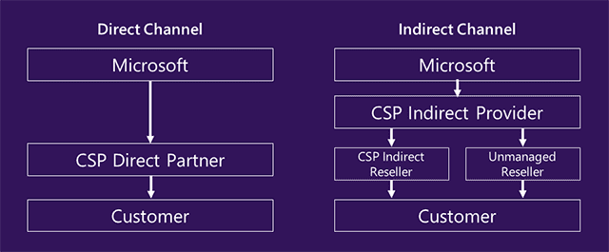

1. 43. Question

A company plans to migrate to a hybrid cloud infrastructure. You need to determine where to manage the different features after the hybrid deployment is complete.  
“Configure Compliance”.

* +  On-Premise
  +  Microsoft 365 only
  +  Both Microsoft 365 and On-Premise

Unattempted

1. 44. Question

A company plans to migrate to a hybrid cloud infrastructure. You need to determine where to manage the different features after the hybrid deployment is complete.  
“Configure MFA for cloud services”

* +  Microsoft 365 only
  +  On-Premise only
  +  Both Microsoft 365 and On-Premise

Unattempted

1. 45. Question

You are the Microsoft administrator for a company all staff must use Microsoft Outlook to access corporate email. When users access outlook on mobile devices they must use a PIN to open the application. You need to implement a Microsoft intune policy to enforce the security requirements which policy should you use?

* +  App protection
  +  Device compliance
  +  App configuration
  +  Device configuration

Unattempted

App protection policies make sure that the app-layer protections are in place. For example, you can:  
Require a PIN to open an app in a work context  
Control the sharing of data between apps  
Prevent the saving of company app data to a personal storage location

<https://docs.microsoft.com/en-us/intune/app-protection-policy>

1. 46. Question

A company assigns a Microsoft 365 license to each employee. You need to install Microsoft Office 365 Enterprise on each employee device. Which three methods can you use? Each correct answer presents a complete solution.  
NOTE: Each correct selection is worth one point.

* +  Use the Office Deployment Tool (ODT) to download installation files to a local distribution source. Install Office 365 Enterprise by using the downloaded files.
  +  Use System Center Configuration Manager (SCCM) to deploy Office 365 Enterprise from a local distribution source.
  +  Download the Office 365 Enterprise Windows Installer (MSI) package. Install Office 365 Enterprise from a local distribution source.
  +  Use System Center Configuration Manager (SCCM) to deploy Office 365 Enterprise from an Office Windows Installer(MSI) package
  +  Enable users to download and install Office 365 Enterprise from the Office 365 portal.

Unattempted

<https://docs.microsoft.com/en-us/deployoffice/teams-install>  
<https://docs.microsoft.com/en-us/deployoffice/deploy-office-365-proplus-from-the-cloud>  
<https://docs.microsoft.com/en-us/deployoffice/deploy-office-365-proplus-with-system-center-configuration-manager> <https://docs.microsoft.com/en-us/deployoffice/deploy-office-365-proplus-from-a-local-source>

1. 47. Question

An organization plans to deploy Microsoft Office 2019 or Office 365 Enterprise. What are the two advantages of Office 365 Enterprise over Microsoft Office 2019? Each correct answer presents a complete solution. (Choose two.)  
NOTE: Each correct selection is worth one point.

* +  Fully functional Office mobile apps are free to install and use.
  +  A single license may be deployed to multiple devices.
  +  Features remain constant throughout the lifetime of the applications.
  +  Office 365 Enterprise includes downgrade rights.

Unattempted

A single subscription of Office 365 Enterprise allows you to install Office 365 on up to 5 devices.  
Office 365 Enterprise includes a fully functional, free to use mobile apps i.e Outlook, Teams & Yammer.  
Office 365 subscriptions (E3, E5, etc.) do not allow for downgrading.  
Office 365 Enterprise is updated automatically. Updates include updates to existing features as well as new features being added to the product.  
<https://support.office.com/en-us/article/what-s-new-in-office-online-fc1de049-98f3-46da-a5aa-da4a19c3e909?ui=en-USandrs=en-USandad=US>

1. 48. Question

A company has a Microsoft 365 subscription that includes Office apps.  
A user has identified a new issue while working with an app. When the user attempts to create a support request, the following message displays:  
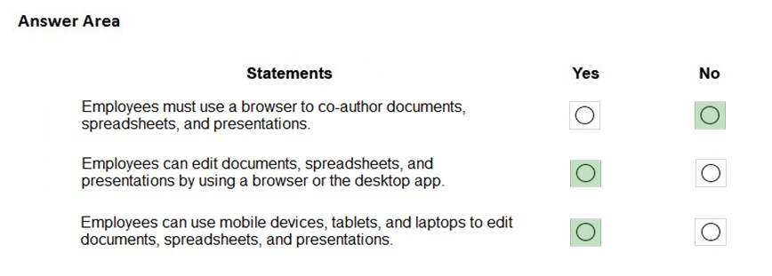

You need to determine the cause of the error message.

What is the cause?

* +  The user account is not a member of the global admin role
  +  The company does not have Premier support.
  +  The user does not have a license assigned for the app.
  +  The user account is disabled.

Unattempted

If you get the message “You don’t have permission to access this page or perform this action,” you aren’t an admin.

<https://docs.microsoft.com/en-us/microsoft-365/admin/admin-overview/admin-overview?view=o365-worldwide>

1. 49. Question

You are an IT Administrator for a  large company with Office 365 global admin account. You need to follow one of the following concepts to decide when users will get a Windows release. Please choose the best answer.

* +  Windows Insiders
  +  Service channel
  +  Deployment ring
  +  Service Branch

Unattempted

While servicing channels determine the update cadence, deployment rings are the mechanism used to specify who will be receiving software from a particular servicing channel.  
More info:  
<https://docs.microsoft.com/en-us/windows/deployment/update/waas-deployment-rings-windows-10-updates>

1. 50. Question

You are in Microsoft 365 administrator for a company stop user experience is an issue with SharePoint online you need to resolve the issue which two options can you use?  
Note that each correct answer presents a complete solution.

* +  create a service request from SharePoint portal
  +  create a new service request from Microsoft 365 admin center
  +  go to the SharePoint admin center and create a support request
  +  contact Microsoft Technical Support by telephone

Unattempted

1. 51. Question

.The company plans to purchase Microsoft 365 enterprise licenses which two options can you use.  
Each correct answer represents a complete solution.

* +  with an enterprise agreement subscription from Microsoft
  +  from the Microsoft retail store
  +  from the Microsoft website using it corporate credit card
  +  from some company which is a cloud solution provider CSP

Unattempted

<https://docs.microsoft.com/en-us/microsoft-365/commerce/licenses/subscriptions-and-licenses?view=o365-worldwide>

1. 52. Question

Which Microsoft 365 feature utilizes biometrics?

* +  Windows Information Protection
  +  Windows Defender ATP
  +  Windows Hello for Business
  +  Windows advanced biometric scanner
  +  AIP

Unattempted

In Windows 10, Windows Hello for Business replaces passwords with strong two-factor authentication on PCs and mobile devices. This authentication consists of a new type of user credential that is tied to a device and uses a biometric or PIN.  
<https://docs.microsoft.com/en-us/windows/security/identity-protection/hello-for-business/hello-identity-verification>

1. 53. Question

Let’s assume that you have been hired by ABC company as a security administrator for their Microsoft 365 environment. You have been advised to ensure that employees accessing the system from outside the corporate network must use corporate devices. Which tool could you use to meet this organizational requirement?

* +  MFA
  +  Conditional Access
  +  Access reviews
  +  On-Premise data gateway

Unattempted

Conditional Access policies at their simplest are if-then statements, if a user wants to access a resource, then they must complete an action. Another Example: A payroll manager wants to access the payroll application and is required to perform multi-factor authentication to access it.

1. 54. Question

Exchange Online hybrid is an example of what kind of cloud deployment model?

* +  Service Cloud
  +  Public Cloud
  +  Private Cloud
  +  Hybrid Cloud

Unattempted

A hybrid deployment offers organizations the ability to extend the feature-rich experience and administrative control they have with their existing on-premises Microsoft Exchange organization to the cloud. A hybrid deployment provides the seamless look and feel of a single Exchange organization between an on-premises Exchange organization and Exchange Online. In addition, a hybrid deployment can serve as an intermediate step to moving completely to an Exchange Online organization.

1. 55. Question

Identify three core components of Microsoft 365?

* +  Enterprise Mobility+Security
  +  Office 365
  +  Windows 10 Enterprise edition
  +  Windows Server 2019
  +  Windows 10 Home edition
  +  Microsoft Azure Sentinel

Unattempted

Microsoft 365 is a bundle of services that includes Office 365, Windows 10 Enterprise and Enterprise Mobility + Security (EMS).